**Joins and subqueries**

# 1. Find the upward recommendation chain for member ID 27

**Query**: with recursive recommenders(recommender) as ( select recommendedby from cd.members where memid = 27 union all select mems.recommendedby from recommenders recs inner join cd.members mems on mems.memid = recs.recommender ) select recs.recommender, mems.firstname, mems.surname from recommenders recs inner join cd.members mems on recs.recommender = mems.memid order by memid desc

**SQLOUTPUT:**

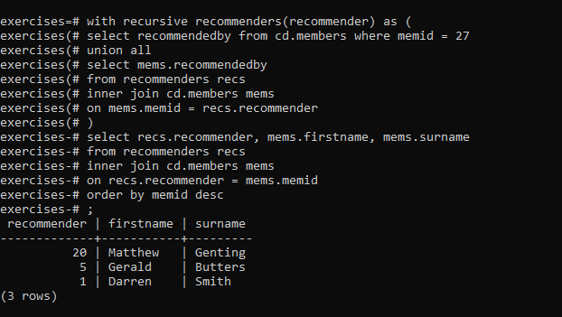

**2. Find the downward recommendation chain for member ID Query**: with recursive recommendeds(memid) as ( select memid from cd.members where recommendedby = 1 union all select mems.memid from recommendeds recs inner join cd.members mems on mems.recommendedby = recs.memid ) select recs.memid, mems.firstname, mems.surname from recommendeds recs inner join cd.members mems on recs.memid = mems.memid order by memid

**SQLOUTPUT:** 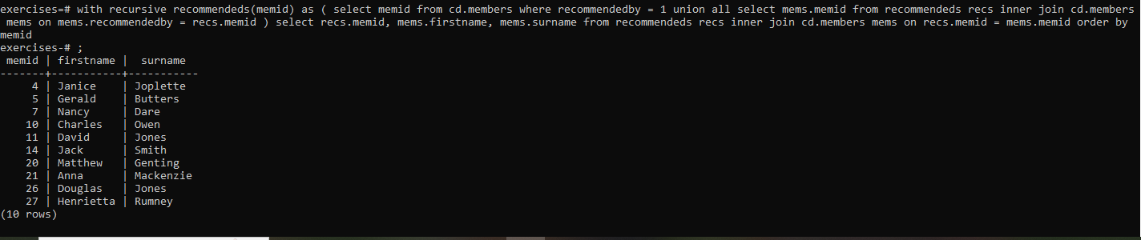

**3. Produce a CTE that can return the upward recommendation chain for any member**

**Query**:with recursive recommenders(recommender, member) as ( select recommendedby, memid from cd.members union all select mems.recommendedby, recs.member from recommenders recs inner join cd.members mems on mems.memid = recs.recommender ) select recs.member member, recs.recommender, mems.firstname, mems.surname from recommenders recs inner join cd.members mems on recs.recommender = mems.memid where recs.member = 22 or recs.member = 12 order by recs.member asc, recs.recommender desc

**SQLOUTPUT:** 